|  |
| --- |
| Local Search Optimization Guide v1.0 |
| Maximizing your performance on search engines |
|  |
| This guide will help markets improve their websites to be more relevant to users and how they search for restaurants |
|  |

Local Search Optimization Guide v1.0

Maximizing your performance on search engines

# Critical for our Industry

The use of the internet to find information about goods and services has been increasing on every continent. Smartphones have only accelerated this as users learn how useful location services are when looking for a local business. This is especially true for restaurant services as search engines have replaced telephone books in almost every country. Search Engine Optimization (SEO) can be a way to grow the business and earn customers that may have never otherwise found out about our restaurants.

# Basics of Search

Search engines want to provide customers with the best possible content. They utilize “crawlers” that scan every possible page on the internet and store them in a searchable form. These engines use algorithms to determine which content is most suitable to the user. This form of search is known as organic search. Alternatively, companies can pay to have specific results displayed in a result. This form of search is known as paid search. Both are important to our business, but this guide is intended on optimizing organic search. We want to focus on organic as implementing these recommendations will result in lower cost paid search as well as improve organic rankings which are more popular with users. Figure 1 shows how organic and paid search are typically displayed to users on Google.

**Figure 1: Basic Components of Search**

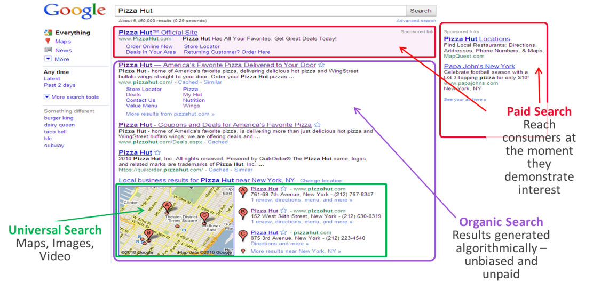

## Basic Page Optimization

Search algorithms constantly evolve to optimize results for user, but there are two key elements that are most critical for optimization.

### Title Tags

Title Tags are the titles on every page of your website. If you look at the top of your browser in the tab you will see part of the title tag. Holding your mouse pointer over the tab will also display the Title Tag. Figures 2 and 3 have the Title Tag used for Pizza Hut US homepage and the Wings landing page. This tag is given top priority by all search engines so a good description is necessary. Keep the title tag between 40-60 characters and make it relevant for customers. Including daypart menus, delivery, and catering are all great examples of how to leverage the Title Tag.

**Figure 2: Title Tag – Pizza Hut USA - Homepage**

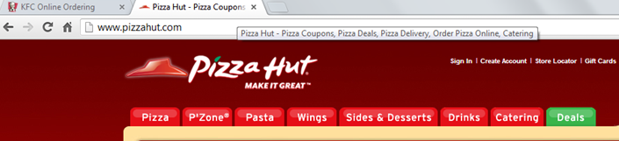

**Figure 3: Title Tag – Pizza Hut USA – Wings Category Page**

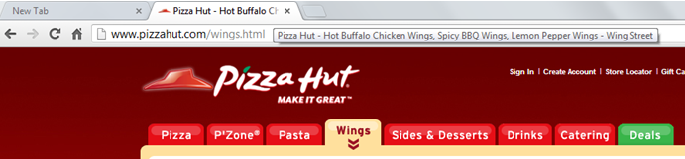

### Meta Descriptions

The Meta Description is important as it is the description users see in the search results and will influence users to click on the link. This is an opportunity to use descriptions for our products and services. Use one or two sentences no longer than 150 characters. Figure 4 below has some examples for KFC.

**Figure 4: Meta Description – KFC US and KFC Singapore**

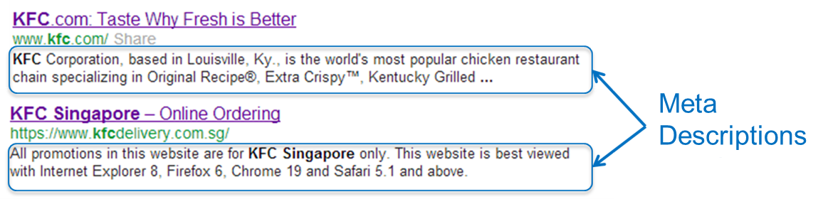

## Local Restaurant SEO

Figure 1 includes a section called Universal Search, an area designated for search results for video, images, and more importantly for us: maps. This allows users to find our stores physical location which is becoming more important every day. The use of smartphones with location services makes this section of search a “killer” application for many users. Optimizing for local search provides benefits for both mobile users and desktop browser users as they leverage the same algorithms. Some simple steps can be used to excel in this area.

**Figure 5: Local Search Results**

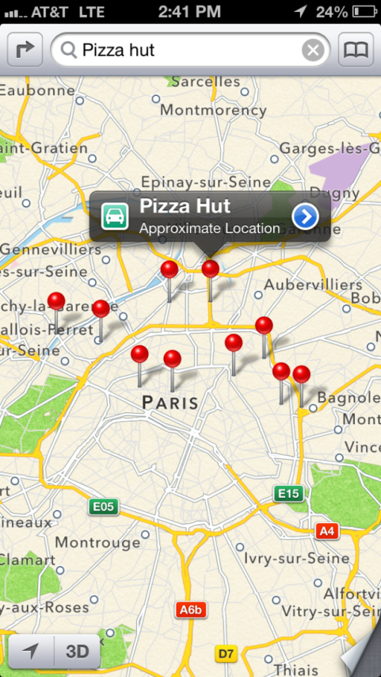 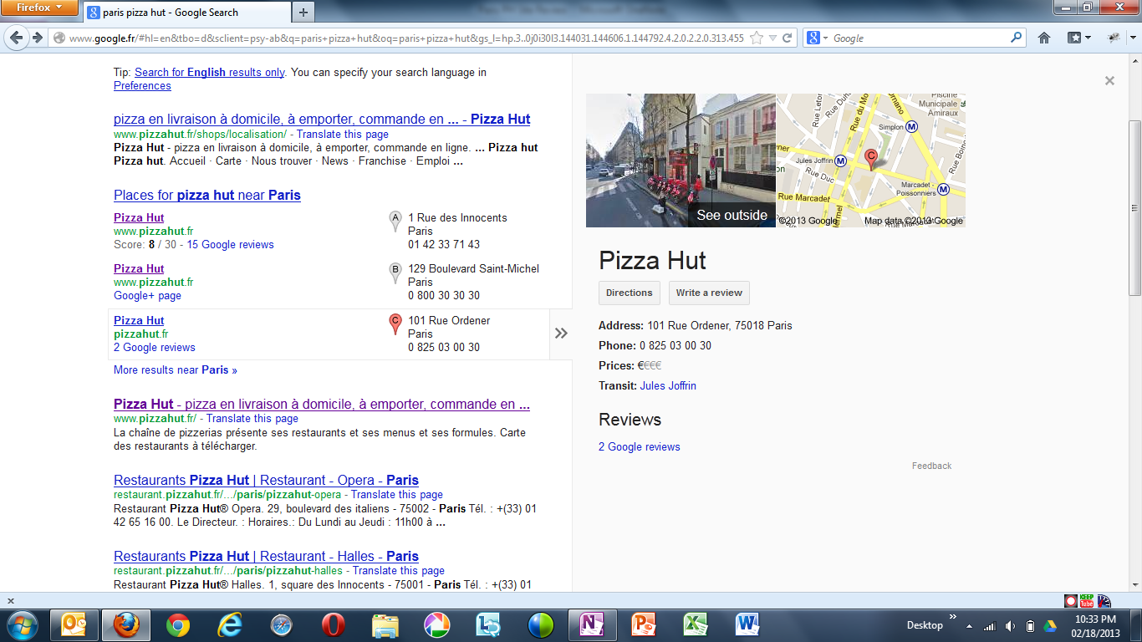

### Step 1: Get Listed with Engines

Three primary search engines are used in our markets. It is important to register our stores with all three, although Google is dominant in most markets. To do this, the following links can be used:

* + google.com/placesforbusiness
  + listings.local.yahoo.com
  + ssl.bing.com/listings

|  |  |
| --- | --- |
|  | The information used in this listing should be as robust as possible, but with a customer focus. Be sure to include pictures of the store, hours of operation (by day), phone number, videos, etc...Be sure to claim the business as an owner, as this will give a higher ranking (vs unclaimed businesses.)  For markets with many locations, work with your local Google, Bing, or Yahoo account manager to bulk load the store information or to setup ongoing automated feeds. |

### Step 2: Optimize Pages for Local

Most of our sites include store locator functionality, which means we have the necessary data for optimizing for local search. In order to win at local search, we recommend markets create Store Landing Pages. This are simple pages that contain basic store information such as physical address, phone number with one key difference: The Title Tag should include City and State (or region). The algorithms used for local search will heavily weigh this information and should elevate our brands to the top of most search request. These store landing pages should also link back to the homepage. Figure 6 has an example of how this is done with Pizza Hut US. As you can see, the actual URL has the state, city and postal code of the store. Combined with the physical address included in the Title Tag, the search engines think this is great content to share with users. Figure 6 also includes a sample of how the type of information displayed in the store landing page.

**Figure 6: Store Landing Page example for Pizza Hut US**

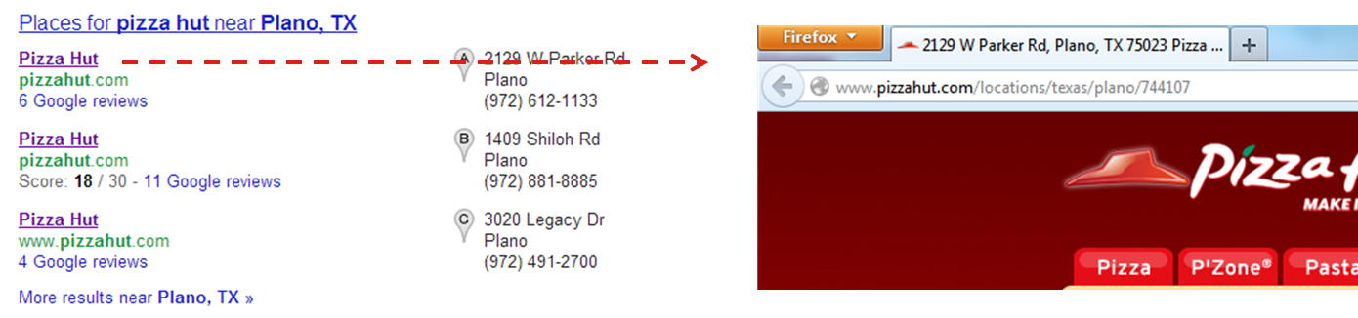

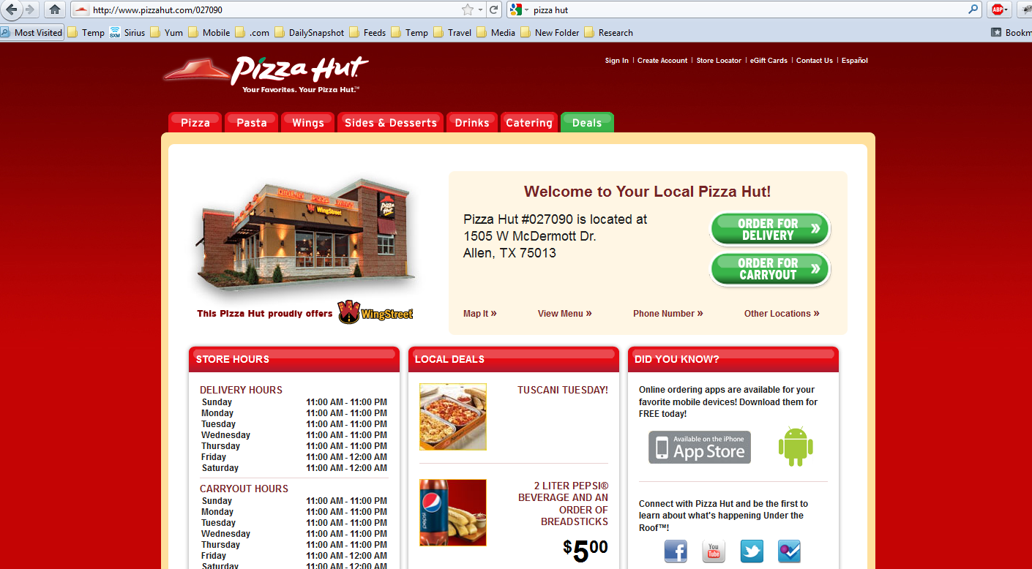

This process works very well as you can see in another example in Figure 7 from Singapore. This example is the result set when you conduct a search for “Hamburger Restaurant” while you are in Singapore. The reason why Rumah Makan shows up first is because they have store landing pages for their stores which include the city in the URL and Title Tag.

**Figure 7: Singapore Example**

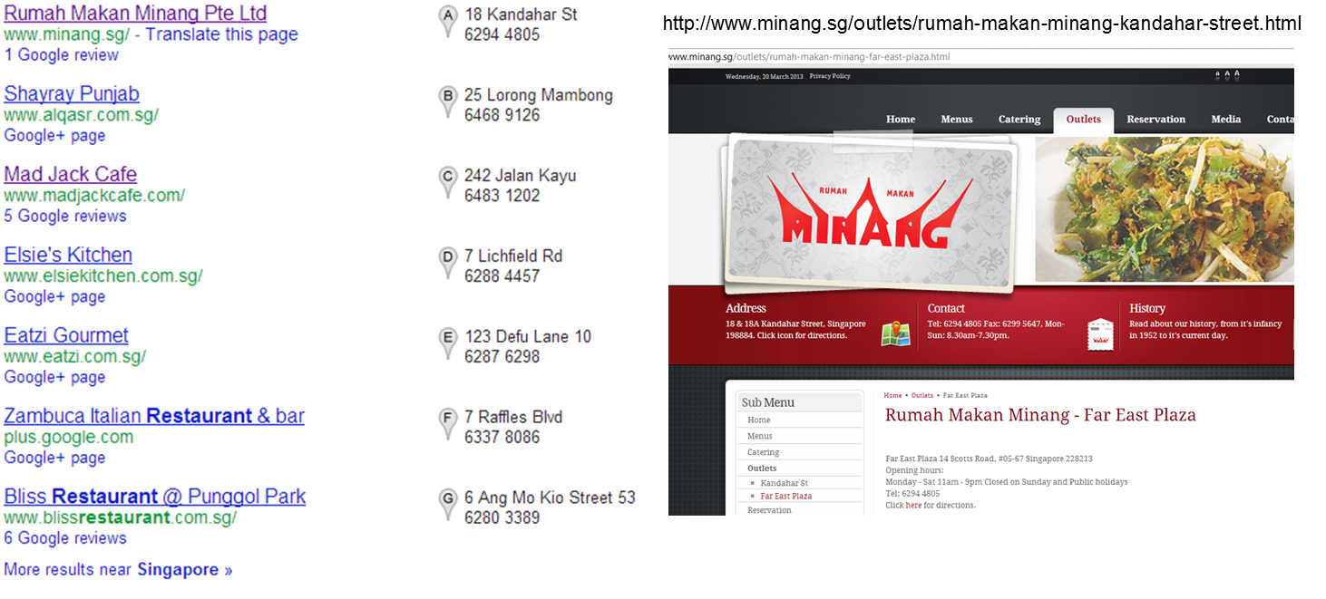

### Step 3: Collaborate with others

Reviews are important to local search algorithms. Encourage customers and team members to conduct honest reviews of our restaurants on local restaurant search sites. In the US, sites like Yelp and Urban Spoon are popular. Other sites like Trip Advisor are also very popular for international destinations.

Social check-ins are also important. Google, Facebook, and Foursquare check-ins are used by the search engines to help rank results. Encourage customers and team members by creating promotional incentives.